Supplementary Appendix S1

Contents
- Deriving transition frequencies from stage-specific sample sizes (p. 2)
- Sampling distribution for a single MPM (p. 3)
- Sampling distribution for a mean or pooled MPM (p. 6)
- Age-from-stage analyses (p. 9)
- Boundary estimates of survival (p. 10)
- References (p. 13)

1. Deriving transition frequencies from stage-specific sample sizes
For most of the MPMs in our analysis, transition rates were initially estimated from ratios of integers (e.g. based on the observed number of individuals transitioning between stage classes over a given interval, or the observed number of seedlings at time t per reproductive individual at time t-1). In these cases, we used stage-specific sample sizes (the integer denominators originally used in calculating the transition rates) together with the original transition rates to back-calculate the integer numerators. If A is a matrix of transition rates calculated from ratios of integers, and n is a vector of corresponding stage-specific denominators, then the integer numerator $x_{ij}$ corresponding to the transition rate in row i and column j must be
$$x_{ij}=round\left({n_{j}A}_{ij}\right).$$
Similarly, if U is a matrix containing only the survival-related transitions within A, then the number of individuals from stage j that died during the projection interval must have been
$x_{dj}=round(n_{j}\left(1-\sum_{i}{U_{ij}}\right))$.
For example, given the following projection matrix,
$$A=\left(\begin{matrix} & & & F_{14} \\ U_{21} & U_{22} & & \\ & U_{32} & U_{33} & U_{34} \\ & & U_{43} & U_{44}\end{matrix}\right)=\left(\begin{matrix} & & & 0.191 \\ 0.857 & 0.778 & & \\ & 0.056 & 0.667 & 0.277 \\ & & 0.222 & 0.702\end{matrix}\right),$$
and corresponding stage-specific sample sizes $n=(14, 18, 9, 47)$, the underlying transition frequencies (including death transitions $U_{dj}$ appended as an extra row) must have been
$$\left(\begin{matrix} & & & F_{14} \\ U_{21} & U_{22} & & \\ & U_{32} & U_{33} & U_{34} \\ & & U_{43} & U_{44} \\ U_{d1} & U_{d2} & U_{d3} & U_{d4}\end{matrix}\right)=\left(\begin{matrix} & & & 9/47 \\ 12/14 & 14/18 & & \\ & 1/18 & 6/9 & 13/47 \\ & & 2/9 & 33/47 \\ 2/14 & 3/18 & 1/9 & 1/47\end{matrix}\right).$$
2. Sampling distribution for a single MPM
To generate a sampling distribution for a given MPM (and corresponding derived parameters), we generated 2,000 independent random draws from the sampling distribution of each underlying transition rate. In practice, these draws were made using the conjugate distribution for a given likelihood function (Table S1-1). For example, if $U_{ij}$ is a survival-related transition from stage j to i, estimated based on the observation that $k$ out of the $n$ individuals in stage j survived and transitioned to stage i (and the remaining $n-k$ died), we can model the $U_{ij}$ transition as a binomial sample with k successes in n trials. To draw from the sampling distribution of $U_{ij}$, we rely on the fact that the binomial likelihood function corresponds to a beta distribution with shape parameters $α=1+k$ and $β=1+(n-k)$. We could equivalently use a multinomial likelihood here (and draw from the conjugate Dirichlet distribution), which has the advantage of flexibly scaling to instances with >2 possible outcomes (e.g. an individual from stage j might die, survive and remain in stage j, or survive and grow to stage j+1). For fecundity transitions, we use a Poisson likelihood (drawing from the conjugate gamma distribution) to model the expected number of offspring per individual in a given stage class.

Table S1-1. Sampling distributions for binomial, multinomial, and Poisson likelihoods (Gelman et al. 2014).
Likelihood | Observed data | Sampling distribution
binomial | k successes in n trials | $$beta(α=1+k,β=1+(n-k))$$
multinomial | counts $x_{1},x_{2},…,x_{M}$ of the number of observations of outcomes 1-M | $$Dirichlet(α={(x}_{1}+1,x_{2}+1,…,x_{M}+1))$$
Poisson | k total events from n units | $$gamma(α=1+k,β=n)$$

Example
We illustrate the process of generating an MPM sampling distribution using the transition frequencies from matrix A above,
$$\left(\begin{matrix} & & & F_{14} \\ U_{21} & U_{22} & & \\ & U_{32} & U_{33} & U_{34} \\ & & U_{43} & U_{44} \\ U_{d1} & U_{d2} & U_{d3} & U_{d4}\end{matrix}\right)=\left(\begin{matrix} & & & 9/47 \\ 12/14 & 14/18 & & \\ & 1/18 & 6/9 & 13/47 \\ & & 2/9 & 33/47 \\ 2/14 & 3/18 & 1/9 & 1/47\end{matrix}\right).$$
The survival-related transitions from a given stage j (i.e. within a given column, including death) represent a simplex of probabilities that sum to 1, and so we model this vector of transitions using a multinomial likelihood. We draw from the multinomial sampling distribution using the conjugate Dirichlet distribution with concentrations parameters $α_{m}=x_{m}+1$, where $x_{m}$ is a count of the number of observations of outcome m, as in
$$\left(U_{21}, U_{d1}\right) \sim Dirichlet(α=\left(13, 3\right))$$
$$\left(U_{22},U_{32}, U_{d2}\right) \sim Dirichlet(α=\left(15, 2, 4\right))$$
$$\left(U_{33},U_{43}, U_{d3}\right) \sim Dirichlet(α=\left(7, 3, 2\right))$$
$$\left(U_{34},U_{44}, U_{d4}\right) \sim Dirichlet\left(α=\left(14, 34, 2\right)\right).$$
For the sole fecundity transition, we assume a Poisson likelihood and therefore draw from the conjugate gamma distribution, as in
$$F_{14} \sim gamma\left(α=1+9, β=47\right).$$
A set of actual draws from the sampling distributions above are depicted in Table S1-2 below.

Table S1-2. Point estimates and draws from the sampling distribution for transition rates and derived parameters (including the equilibrium population growth rate λ, damping ratio ρ, and life expectancy L) from a single MPM.
Draw | $$A$$ | $$λ$$ | $$ρ$$ | $$L$$
Point estimates from original MPM
 | $$\left(\begin{matrix} & & & 0.191 \\ 0.857 & 0.778 & & \\ & 0.056 & 0.667 & 0.277 \\ & & 0.222 & 0.702\end{matrix}\right)$$ | 0.96 | 1.31 | 7.84
Draws from the sampling distribution
1 | $$\left(\begin{matrix} & & & 0.138 \\ 0.885 & 0.715 & & \\ & 0.149 & 0.511 & 0.293 \\ & & 0.440 & 0.697\end{matrix}\right)$$ | 1.00 | 1.61 | 16.66
2 | $$\left(\begin{matrix} & & & 0.116 \\ 0.752 & 0.754 & & \\ & 0.039 & 0.313 & 0.219 \\ & & 0.481 & 0.717\end{matrix}\right)$$ | 0.91 | 1.25 | 5.08
… | $$…$$ | $$…$$ | $$…$$ | $$…$$
2000 | $$\left(\begin{matrix} & & & 0.354 \\ 0.729 & 0.553 & & \\ & 0.008 & 0.561 & 0.273 \\ & & 0.162 & 0.714\end{matrix}\right)$$ | 0.86 | 1.61 | 2.70

3. Sampling distribution for a mean or pooled MPM
In modeling sampling uncertainty for mean MPMs, it is difficult to decide whether one should consider the process of averaging matrix elements across successive year-to-year transitions as a simple transformation or as an implicit statistical model (i.e. yielding a sample mean of a Gaussian distribution). The latter option seems more rigorous, but implies that we should also account for uncertainty in that sample estimate (i.e. in addition to the within-year uncertainty in a given transition rate there is also uncertainty in the long-term average due to year-to-year variation). However, among the populations in COMPADRE with temporal replication (i.e. >1 annual MPM per population), the median number of years of replication is only three, which means that the temporal component of uncertainty will often be extreme.
A separate challenge in treating matrix averaging as an implicit statistical model is that the averaging has usually been done on a different scale than we would use in a statistical model. That is, the survival and reproduction transitions in a mean MPM have been averaged on the scale of the transition (probability and ratio, respectively), whereas in a statistical model it would usually be more appropriate to average them on the logit and log scales, respectively. For example, a sequence of survival-related transitions $\left[0.01, 0.3, 0.2\right]$ averaged arithmetically yields 0.17, but averaged on the logit scale and then back-transformed yields 0.09.
For the present study, we therefore elected to treat averaging as a simple transformation to be performed on the scale of the transition. This approach has the advantage of fidelity to the actual transition rates provided in COMPADRE — we are estimating sampling uncertainty for the transition rates as they were calculated and presented in the scientific literature, rather than for transition rates that could have been calculated from the underlying data using a more nuanced statistical model. That said, in general, we strongly advocate for an increased use of hierarchical models to estimate transition rates (e.g. Dalgleish et al. 2009) — to account for unbalanced sample sizes and partially-pooled information across sites or years.
To draw from the sampling distribution of a mean MPM $\hat{A}$, which was originally derived by averaging matrix elements across component MPMs $A_{1}, A_{2}, …, A_{N}$, we would first generate an independent draw from the sampling distribution of each component MPM (as described in Section 2), and then take an arithmetic average of each transition rate $a_{ijn}$ (row i, column j, year n) across the draws of the N component MPMs, as in
$$\hat{a_{ij}}=\frac{1}{N}\sum_{n}{a_{ijn}}.$$
If, for a given analysis, our interest is in the mean MPM, then derived parameters such as population growth rate, damping ratio and life expectancy, are calculated from draws of that mean MPM (i.e. first we calculate average transition rates to obtain a mean MPM and then we calculate the derived parameters, rather than calculating derived parameters from each component MPM and subsequently averaging those parameters). We illustrate an example of drawing from the sampling distribution of a mean MPM in Table S1-3 below.
Table S1-3. Point estimates and draws from the sampling distribution for transition rates and derived parameters (the equilibrium population growth rate λ, damping ratio ρ, and life expectancy $l_{0}$) from a mean MPM $\hat{A}$, calculated as an arithmetic average across three component MPMs ($A_{1997-1998}, A_{1998-1999}, A_{1999-2000}$).
Draw | $$A_{1997-1998}$$ | $$A_{1998-1999}$$ | $$A_{1999-2000}$$ |  | $$\hat{A}$$ |  | $$λ$$ | $$ρ$$ | $$l_{0}$$
Point estimates from original MPMs
 | $$\left(\begin{matrix} & 1.00 \\ 0.75 & 0.36\end{matrix}\right)$$ | $$\left(\begin{matrix} & 0.88 \\ 0.62 & 0.29\end{matrix}\right)$$ | $$\left(\begin{matrix} & 1.04 \\ 0.69 & 0.13\end{matrix}\right)$$ |  | $$\left(\begin{matrix} & 0.97 \\ 0.69 & 0.26\end{matrix}\right)$$ |  | 0.96 | 1.37 | 1.93
Draws from the sampling distributions
1 | $$\left(\begin{matrix} & 1.85 \\ 0.47 & 0.34\end{matrix}\right)$$ | $$\left(\begin{matrix} & 1.00 \\ 0.61 & 0.26\end{matrix}\right)$$ | $$\left(\begin{matrix} & 0.95 \\ 0.74 & 0.20\end{matrix}\right)$$ |  | $$\left(\begin{matrix} & 1.26 \\ 0.61 & 0.27\end{matrix}\right)$$ |  | 1.02 | 1.35 | 1.83
2 | $$\left(\begin{matrix} & 0.90 \\ 0.53 & 0.28\end{matrix}\right)$$ | $$\left(\begin{matrix} & 0.86 \\ 0.31 & 0.27\end{matrix}\right)$$ | $$\left(\begin{matrix} & 1.08 \\ 0.63 & 0.30\end{matrix}\right)$$ |  | $$\left(\begin{matrix} & 0.95 \\ 0.49 & 0.28\end{matrix}\right)$$ |  | 0.84 | 1.52 | 1.69
… | $$…$$ | $$…$$ | $$…$$ |  | $$…$$ |  | $$…$$ | $$…$$ | $$…$$
2000 | $$\left(\begin{matrix} & 0.97 \\ 0.51 & 0.54\end{matrix}\right)$$ | $$\left(\begin{matrix} & 0.75 \\ 0.26 & 0.34\end{matrix}\right)$$ | $$\left(\begin{matrix} & 1.04 \\ 0.73 & 0.13\end{matrix}\right)$$ |  | $$\left(\begin{matrix} & 0.92 \\ 0.50 & 0.34\end{matrix}\right)$$ |  | 0.87 | 1.63 | 1.75

4. Age-from-stage analyses
To estimate mature life expectancy (L) and shape (S), we first used age-from-stage methods (Cochran and Ellner 1992, Caswell 2001 Sec. 5.3) to derive a survivorship trajectory from each MPM, using the first stage class(es) with positive reproduction as our starting point. Specifically, for a given MPM, we initiated a population vector with all individuals placed in the first reproductive stage class (i.e. the earliest stage class with a rate of sexual reproduction greater than zero). We then repeatedly projected this population vector through the U component of the relevant MPM, tracking the proportion of surviving individuals at each time step (i.e. at each age class following reproductive maturity). In some life cycles there is more than one stage class in which an individual could first achieve reproductive maturity. In these cases we set the initial population vector in proportion to the probability that an individual would first attain reproductive maturity in each of the relevant stage classes, based on Markov chain absorption probabilities starting from the first non-seed stage class. For example, consider the MPM for Astragalus peckii depicted in Table S1-4. The three reproductive stage classes (small, medium, and large) can each be reached via a single growth transition from the first non-seed stage (seedling), and therefore an individual plant could first achieve reproductive maturity in any of the three reproductive stage classes. To obtain a starting population vector n0 we would set the three reproductive stage classes to absorbing states, set a population vector with all individuals in the first non-seed stage (i.e. seedling), and then calculate absorption probabilities to each of the reproductive stage classes.
When deriving a survivorship trajectory from an MPM, it is guaranteed that the apparent mortality rate will approach a plateau as the stage distribution approaches its stable equilibrium (Horvitz and Tuljapurkar 2008). Such plateaus do not necessarily reflect age patterns that exist in the actual population, but rather are mathematical artifacts of stage-based MPMs. To avoid bias from artifactual mortality plateaus, we calculated shape (S) from truncated survivorship trajectories, limited to the period prior to a cohort reaching its quasi-stable distribution, QSD, based on a distance threshold of 1%. ‘Distance’ here refers to the Euclidean distance between the population vector at a given time step in its projection (starting from the stage distribution of reproductive maturity, n0, as described above), and the stable stage distribution with respect to the U component of the relevant MPM. For example, with respect to the MPM for Astragalus peckii depicted in Table S1-4, starting from the stage distribution of reproductive maturity, the population vector projected through U reaches a distribution within 1% of the stable stage distribution after 5 projection intervals (Fig. S1-1). We therefore truncate the survivorship trajectory to the first five projection intervals (x≤5) when calculating shape. Given our particular measure of shape, not truncating survivorship at the QSD would have the effect of pulling all values of shape toward zero, indicating relatively more constant patterns of mortality with increasing age. This would occur because, as described above, apparent mortality is guaranteed to plateau as the population vector approaches its stable distribution. The more of this plateau we incorporate into the calculation of shape, the more the overall mortality trajectory will appear to be constant, and the closer to zero the calculated value of shape will be.
When calculating shape from MPMs with bootstrapped transition rates, we could in theory re-calculate the QSD for each of the 2000 draws for a given MPM, and use draw-specific values of QSD to truncate survivorship trajectories. However, we elected to use a fixed value of QSD obtained from the original MPM (i.e. the point estimate MPM in COMPADRE) in the calculation of shape for both the original MPM and the 2000 draws from its sampling distribution.

Table S1-4. Mean matrix population model (MPM) for Astragalus peckii population ‘Bull Flat’ years 2006-2009 (Martin and Meinke 2012), taken from COMPADRE. Survival-related transitions are depicted in black and sexual reproductive transitions are in blue. The population vector corresponding to reproductive maturity (n0) is calculated based on Markov chain absorption probabilities to each reproductive stage class (i.e. small, medium, and large), starting from the first non-seed stage class (i.e. seedling).
 |  | Stage, time t
 |  | Seedbank | Seedling | Small | Medium | Large | n0
Stage, time t+1 | Seedbank | 0.440 | 0 | 0.163 | 11.803 | 67.086 | 0
 | Seedling | 0.020 | 0 | 0.013 | 0.673 | 3.173 | 0
 | Small | 0 | 0.103 | 0.203 | 0.033 | 0.017 | 0.574
 | Medium | 0 | 0.070 | 0.307 | 0.260 | 0.043 | 0.389
 | Large | 0 | 0.001 | 0.053 | 0.583 | 0.690 | 0.037

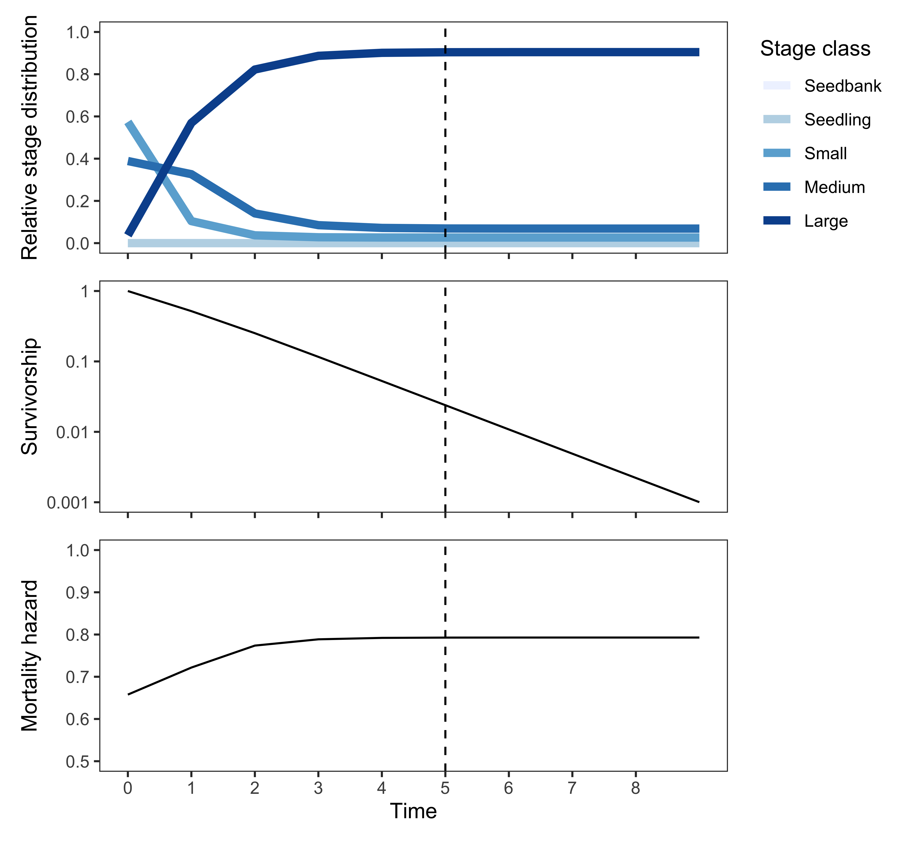
Fig S1-1. Illustration of the quasi-stable distribution, QSD, with respect to the MPM for Astragalus peckii depicted in Table S1-4. The top panel depicts the projection of a population vector initially corresponding to the expected stage distribution at reproductive maturity, through the U component of the corresponding MPM. After five projection intervals the projected stage distribution has attained the QSD (dashed vertical line), falling within a distance of 1% of the ultimate stable stage distribution. As the cohort approaches its stable distribution mortality rates are guaranteed to plateau (bottom panel), and survivorship will decline at an increasingly constant rate (middle panel).
5. Boundary estimates of survival
We observed that point estimates of survival on the boundary of possible values (i.e. estimates approaching either 0% or 100% survival) can sometimes have a strong influence on point estimates of MPM-derived parameters related to survival, such as life expectancy. Here we illustrate an extreme case of this phenomenon using an MPM for a population of the woodland herb Trollius laxus (Scanga 2014; population “T”). The raw transition frequencies underlying the survival-related component of this MPM were as follows (including death transitions $U_{dj}$ appended as an extra row),
$$\left(\begin{matrix} & & & & \\ U_{21} & U_{22} & U_{23} & U_{24} & \\ & U_{32} & U_{33} & U_{34} & \\ & U_{42} & U_{43} & U_{44} & U_{45} \\ & & & U_{54} & U_{55} \\ U_{d1} & U_{d2} & U_{d3} & U_{d4} & U_{d5}\end{matrix}\right)=\left(\begin{matrix} & & & & \\ 9/14 & 47/66 & 11/54 & 1/23 & \\ & 15/66 & 33/54 & 5/23 & \\ & 1/66 & 10/54 & 10/23 & 1/10 \\ & & & 7/23 & 9/10 \\ 5/14 & 1/66 & 0/54 & 0/23 & 0/10\end{matrix}\right).$$
Note that among the three largest stage classes there were no observed deaths within the sample of tagged plants, and therefore the naïve point estimate for annual survival for each of these stages is 100%. These boundary estimates of survival lead to a point estimate for mature life expectancy (131.5 years) that is much higher than the vast majority of the corresponding sampling distribution (mean 29.7 years, 95% interval 13.1–74.7 years) (Fig. S1-2b). Likewise, the boundary estimates of survival yield a survivorship trajectory that is much shallower than the majority of the corresponding sampling distribution (Fig. S1-2c).

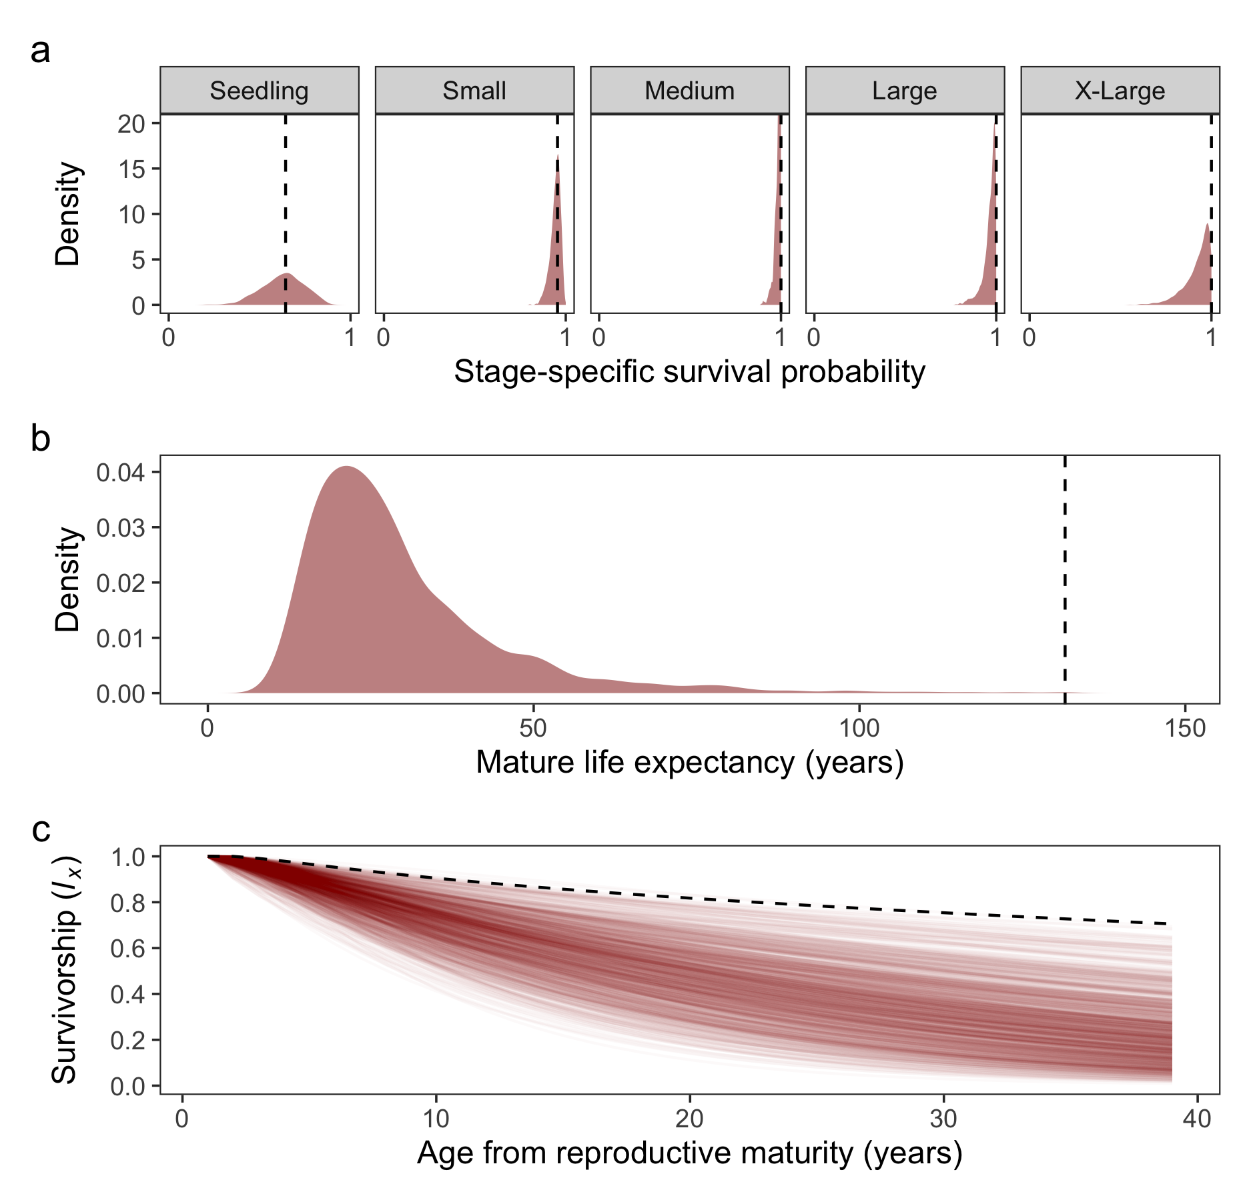
Fig. S1-2. Illustration of how point estimates of survival on the boundary can have a strong influence on point estimates of some MPM-derived parameters. Panel depicts point estimates (dashed black lines) and sampling distributions (red density kernels or lines) for parameters of an MPM for the woodland herb Trollius laxus (Scanga 2014, population “T”). Specifically, panels depict (a) stage-specific survival rates, (b) life expectancy from reproductive maturity, and (c) survivorship from reproductive maturity (limited to the age at which the point estimate cohort reaches the quasi-stable distribution, as described in the main text).

4. References
Caswell, H. (2001) Matrix population models: construction, analysis, and interpretation, 2nd ed. Sinauer, Sunderland, MA.
Cochran, M. E., and Ellner, S. (1992) Simple Methods for Calculating Age-Based Life History Parameters for Stage-Structured Populations. Ecological Monographs, 62, 345-364.
Dalgleish, H. J., Koons, D. N., & Adler, P. B. (2010) Can life-history traits predict the response of forb populations to changes in climate variability? Journal of Ecology, 98, 209-217.
Gelman, A., Stern, H. S., Carlin, J. B., Dunson, D. B., Vehtari, A., and Rubin, D. B. (2014) Bayesian Data Analysis, 3rd ed. Chapman and Hall/CRC.
Horvitz, C. C., and Tuljapurkar, S. (2008) Stage dynamics, period survival, and mortality plateaus. The American Naturalist, 172, 203-215.
Martin, E. F., and Meinke, R. J. (2012) Variation in the demographics of a rare central Oregon endemic, Astragalus peckii Piper (Fabaceae), with fluctuating levels of herbivory. Population Ecology, 54, 381-390.
Scanga, S. E. (2014) Population dynamics in canopy gaps: nonlinear response to variable light regimes by an understory plant. Plant Ecology, 215, 927-935.

